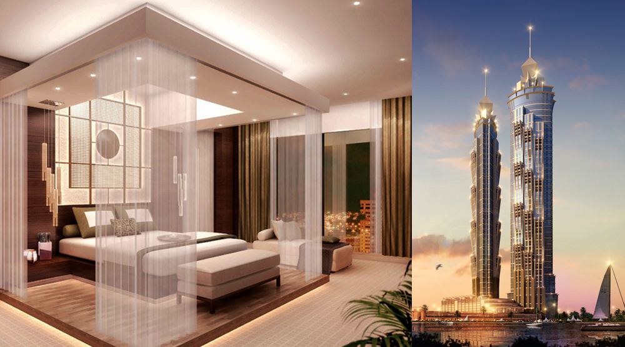

Tour Itinerary
Arrive at Dubai and transfer to JW Marriot Marquis. Evening at leisure or shop around at the market. Night stay at hotel.

Day 02 :Dubai City Tour 9:00 AM -01:00 PM:
Proceed for half-day city tour of Dubai, Are you on time constraint but wish to explore all key cultural, historic and up to date highlights of Dubai? Sun and Sky all-encompassing city tour package is just perfect for you. While a trip to sites including Dubai Creek, Dubai Museum within the 18th century Al Fahidi Fort and Jumeirah Mosque provides a deep insight into the unique Emirati culture and heritage, a drive through Burj Khalifa, Palm Jumeirah dotted with a whole lot of prestigious developments in the form of Burj Al Arab and Atlantis Hotel, and Sheik Zayed Road where most of the city’s most exquisite commercial establishments are concentrated, allows you to experience the long yet unwavering journey of this once-a-fishing village to emerge into an ultra-modern global destination
Burj Khalifa
Skyscrapers don’t get any taller than Burj Khalifa, the tallest structure on the planet. Soaring 2,717 feet (828 meters) high with more than 160 stories, the building has a stepped design that narrows as it climbs syringe-like to the sky
Bringing a new meaning to the term skyscraper, the building is part of the massive Downtown Dubai complex of offices, hotels, shopping malls, entertainment precincts and apartment buildings.
Ride the elevator to the 124th-floor Observation Deck for astounding views over Dubai and the Arabian Gulf, or take a wander through the gardens and fountains of Burj Khalifa Park. Visitors can also shop till they drop in Dubai Mall, the world's largest mall. Along with a huge variety of shops such as Galeries Lafayette, Bloomingdale's and Marks & Spencer, the mall includes an aquarium, ice rink, Sega theme park .
Overnight at hotel.

Day 03 : Desert safari with Dinner 03:00 PM -09:00PM
Day at leisure or go shopping. Get ready for desert safari
TWC desert safari in Dubai is ideal to satiate your desire for thrill and adventure. With our all-inclusive package, go for an exhilarating ride over the desert dunes, ride on camel back, adorn your hands with traditional henna designs, capture photograph in traditional costumes, and eventually bask in the comforts of our
traditionally set Bedouin desert campsite where you can relish finest BBQ dishes and enjoy stupefying performances of our gorgeous belly dancer.

- Pickup from your hotel in Dubai
- Adventurous dune driving
- Sunset Photographic Opportunity
- Camel Riding
- Henna Designing
- Shisha Facility / ‘Hubbllee Bubblee’ Smoking facility
- Arabic Dress photograph opportunity
- Unlimited Soft drinks, Water, Tea & Coffee
- Sand Boarding (Optional – Upon request & availability)
- Quad biking (Additional charge)
- BBQ Dinner with Veg & Non Veg dishes from 5* quality caterers
- Belly Dance Show/ Tanura show by professional artists
- Availability of Alcohol beverages in Camp At separate extra cost
- Separate Toilet facilities for both Men & Women
- Drop back to your hotel or residence in Dubai

Day 4 : Abu Dhabi City Tour 09: AM -06:00 PM
Get reaty for full day Abu Dhabi tour
On an Abu Dhabi city tour, know how the capital city of the United Arab Emirates incredibly merges its rich ancient heritage with the most modern contemporary life
We’ve crafted this tour package with cautiously picked highlights of Abu Dhabi in order to ensure that you don’t miss out to take in its significant sights.
One sight that would for sure command your attention en-route to Abu Dhabi city centre is the astounding and expansive white structure - Sheik Zayed Grand. The tour will further lead you to attractions like stupendous Emirates Palace, bustling the Abu Dhabi city center and then to the mind blowing Corniche.
Before we head out to Abu Dhabi’s most modern attractions including Ferrari World and Yas Island, we’ll take you to Heritage Village and Abu Dhabi Museum that serves as a window to the region’s past. Eventually, the trip culminates with a visit to Abu Dhabi Marina Mall. Upon a full-day, unforgettable trip, we would drop you back to your rendezvous spot in Dubai.

- Pick up from your hotel or residence in Dubai / Sharjah
- Photographic opportunity at Yas Island Ferrari world
- Visit to Sheikh Zayed Mosque
- Photographic opportunity at Emirate Palace Hotel & President Palace and near Miraj Islamic ART Gallery
- Visit to Heritage village and Museum of Abu Dhabi
- Drive through Corniche Road
- Date Market
Drop Back to your hotel in Dubai

Day 05 : Dhow Cruise Dinner 7:30 pm-10:30 pm
Breakfast. Day at leisure or go shopping. Get ready in the evening for a Dinner cruise. Enjoy a nice dinner aboard. Night stay at hotel.
Cruise down the tranquil Dubai Creek, steeped in history, to enjoy the panoramic skyline of Dubai from aboard Sun and Sky Floating restaurant. Be in awe of the attractions that represent both grandeur of 21st century and rich heritage of the region, as our dhow gently drifts you along the glossy structures, illumed traditional souks, and historic sand-colored buildings with wind towers lining the creek. Aside from buffet dinner featuring scrumptious international cuisines, you can revel in Tanura show and live music performances aboard.

- Pick up from your hotel in Dubai.
- 2 hour cruising near to Bur dubai and Deira creek area.
- Welcome drinks, Water, Tea & Coffee.
- International buffet dinner with a choice of vegetarian and non-vegetarian dishes.
- Access to fully air-conditioned lower deck and open air upper deck.
- Entertainment shows / Tanura show.
- Magic Show
- Free WiFi
- Separate toilet facilities for men and women.
- Smoking facility at upper deck only.
- Drop back to your hotel in Dubai

Day 06 : Drop off to Airport
Check-out for the airport. Board a flight to way back home.

Package Inclusions :
- Meet & Greet Service at the Dubai International Airport
- 5 Nights accommodation in Dubai
- Half Day Dubai City Tour
- Desert Safari with BBQ Dinner
- Dhow Cruise with Dinner
- Breakfasts at the Hotel
- R/T airport transfers
- Transfers Tours on Seat in Coach basis

Package Exclusions :
- Visa charges are not included
- Any Airfare
- Applicable Peak Season, Christmas, New year surcharges
- Items of Personal Nature
- Travel Insurance
- Service tax extra @ 4% is applicable
- Anything not mentioned above

